For immediate release
SPCA Selangor Media Release

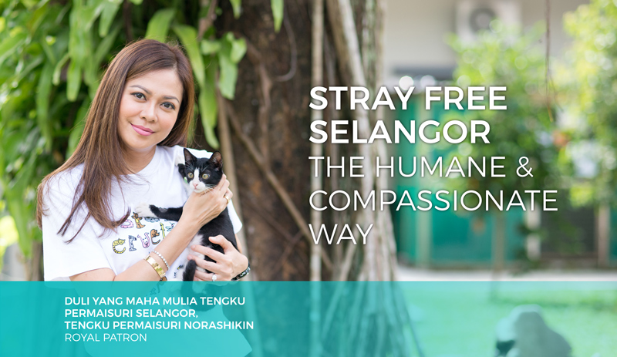

STRAY FREE SELANGOR (SFS) - THE HUMANE AND COMPASSIONATE WAY

SELANGOR, 20 MARCH 2017 -- The stray animals of Selangor are blessed with the support and participation of our beloved DYMM Tengku Permaisuri Selangor Tengku Permaisuri Norashikin, who has kindly consented to be the Royal Patron for STRAY FREE SELANGOR (SFS) - THE HUMANE AND COMPASSIONATE WAY. Selangor will be the first state in Malaysia to work towards an effective yet compassionate stray control programme.

STRAY FREE SELANGOR (SFS) - THE HUMANE AND COMPASSIONATE WAY has a vision of a home/habitat for every soul, focusing on Humane Education, High Volume Spay/Neuter, Government Lobbying for humane, effective and sustainable ways to curb stray populations.

The current preferred stray control method of CATCH-AND-KILL practiced by all Municipal Councils in Malaysia in an effort to reduce strays has proven to be highly ineffective, inhumane, unethical and expensive. In its place, the action plan of STRAY FREE SELANGOR (SFS) – THE HUMANE AND COMPASSIONATE WAY comprises:

HUMANE EDUCATION
Responsible Pet Ownership (RPO), DogCare Program and CatCare Program to be offered in schools, universities and residential communities.
HIGH VOLUME SPAY/NEUTER
Municipal Councils, DVS vets, private vets, rescuers and NGOs to collaborate and achieve high/spay neuter rates in communities.
GOVERNMENT LOBBYING
Lobby for community animals, habitat for spayed/neutered non-aggressive stray dogs and spayed/neutered cat colonies, mandatory spay/neuter and mandatory RPO seminars for dog owners.

The impetus of STRAY FREE SELANGOR (SFS) - THE HUMANE AND COMPASSIONATE WAY is to work towards a radical change in the way Municipal Councils handle strays. CATCH-AND-KILL is ineffective because every time an area is cleared of stray dogs, a vacuum is created. New strays will inhabit the vacuum and the vicious cycle continues.
STRAY FREE SELANGOR (SFS) - THE HUMANE AND COMPASSIONATE WAY seeks to replace CATCH-AND-KILL with Humane Education and Awareness Roadshows to highlight Responsible Pet Ownership, the new Animal Welfare Act specifically Section 24 which lists the Duties of an Owner, and the importance of Spay/Neuter. An SFS fund has been created to provide subsidised spay/neuter for rescuers and the lower income group to assist in spaying and neutering their animals.
We also propose to create Caring and Compassionate Communities (CCC) for Safe Zones where spayed/neutered strays/community animals can live their life free from misery and capture. The CCC will be guided by SPCA guidelines in communities that are interested to embrace the Caring and Compassionate concept. Feeders must be educated on being responsible feeders by catching the strays they feed and spay/neuter them with our subsidised vouchers.
Annual awards will be given to Municipal Councils which make the most progress towards STRAY FREE SELANGOR (SFS) - THE HUMANE AND COMPASSIONATE WAY.

—————————————————

“Let’s come together to make Stray Free Selangor a reality. Hopefully this campaign will be a platform to spearhead a whole nation campaign of Stray Free Malaysia.”
DYMM Tengku Permaisuri Selangor, Tengku Permaisuri Norashikin

“In sowing the seeds of kindness and compassion towards animals, we are also sowing the seeds of kindness and compassion towards human beings.”
Christine Chin, SPCA Selangor Chairman

“Cruelty towards animals cannot be tolerated. All Malaysians, NGOs and relevant authorities must work together to safeguard the welfare of all animals.”
Tan Sri Lee Lam Thye, Patron of SPCA Selangor

-- ENDS --

For more information, kindly contact Christine Chin or Helen Chan at strayfreeselangor@spca.org.my or +60164451007

Note To The Editors:

· The Society for the Prevention of Cruelty To Animals, SPCA Selangor, is an NGO which serves Selangor and The Federal Territory.

· SPCA Selangor was established in 1958, with the aim of protecting defenceless animals and alleviating their suffering.

· The SPCA does not receive any government funding, relying entirely on donations from the public to support its causes, services & activities.

· The SPCA New E.R.A. (Education, Rehoming & Action) Centre at Ampang Jaya temporarily homes unwanted animals while seeking new homes for them under the Managed Adoption Program (MAP). The animals are made up of surrendered pets, rescued cruelty case animals and stray or abandoned animals brought in by Good Samaritans.

· The SPCA would like to work closely with the people of Malaysia to elevate the welfare standards for our Malaysian animals – ensuring they responsibly neuter their pets, provide adequate food, space, exercise, care and medical attention, as well as encouraging them to be responsible neighbours.

